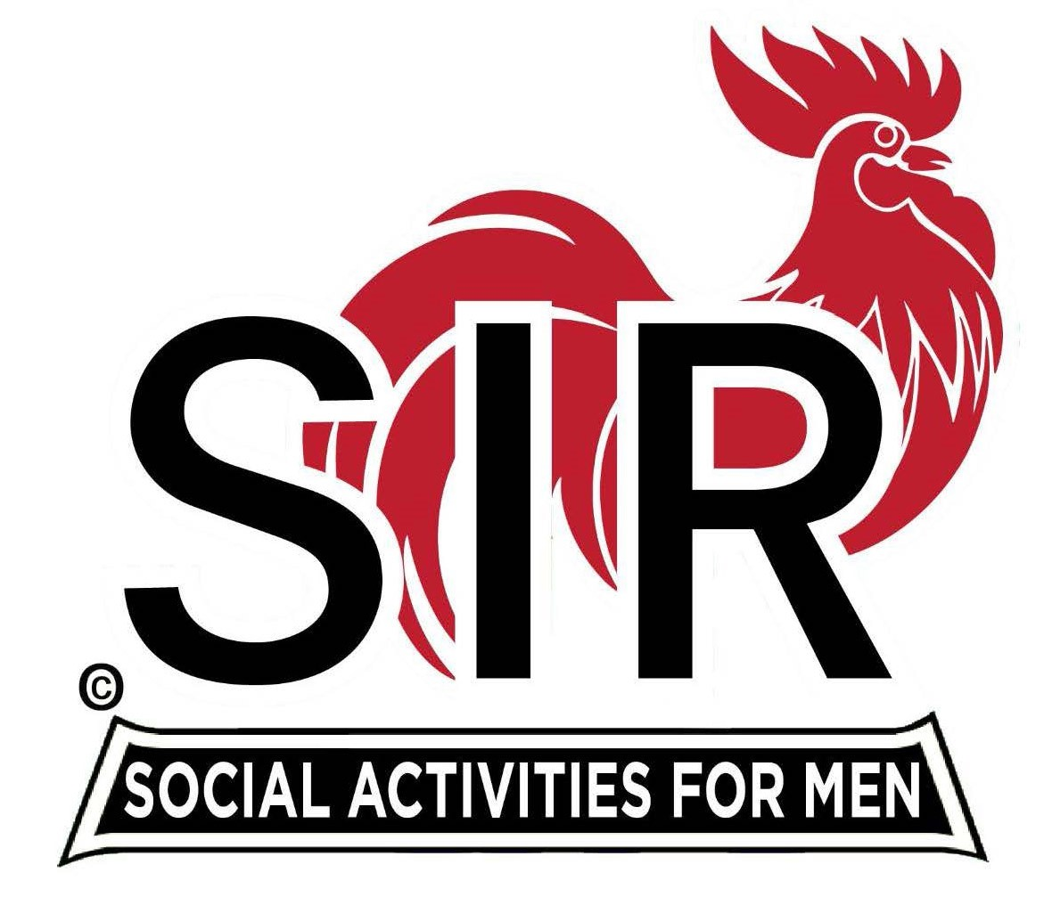
Las Trampas Branch 116
Luncheon Meeting Agenda
February 19, 2024, 10:30 AM

10:30 Check – In
Greeters at the door – Paul Ramacciotti. Joe Datzman
Treasurer Table – Al Satake, Jeff Johnson
Name Tags Table – Mike Schneider
Raffle Table – Ben Bryce, Bob Huck

11:25 Five Minute Call

11:30 Call to order:
Pledge of Allegiance – Big Sir
Invocation – Bill Foulds

11:40 Branch Updates – Big Sir
- New Member – Tony Latini, Sponsor -Gary Halick; Ken Riddings-Sponsor-Bob Colvin:
- Guests- Jim Wohlleb, Sponsor-Don Beioff; Bill Curry, Sponsor-Phil Goff; Garrett Romain, Sponsor-Steve Beck; Rob Stevens, Sponsor-Robin Lemmo
- Spring Fling and Christmas Party

12:00 Lunch Served

12:20 Story Teller – Mac McLoughlin

12:25 Activity Chairs Report - Mike Ward

12:30 Introduce Speaker – Rich Black
- Speaker: Jim Griesemer
  - Topic: AI- “Is it a tool or a companion”

1:05 Speaker Thank You – Big Sir

1:10 Raffle Drawing – Ben Bryce, Bob Huck
Senior Sir – Sheldon Lawrence – Big Sir
Birthday Boys (February) – Little Sir – Paul Russell
Sing Happy Birthday – Music – Dave Williams

1:20 Sing “God Bless America” – Dave Williams

1:25 Closing Remarks / Adjourn – Big Sir

